State of the Science Paper 1
Running head: EDUCATING THE BIPOLAR PATIENT ABOUT STIMULANT USE

Using Motivational Interviewing To Well Inform Bipolar Patients Before Initiating
The Use of Stimulants
Jeffrey T. Day, RN, MSN, FNP-BC, AGPCNP-BC, PMHNP-BC
University of Massachusetts-Boston: College of Nursing
Nursing 716

Fall 2016

State of the Science Paper 2
Response to Reviewer Letter
This letter accompanies this document to outline the revisions requested and the changes made. My PICO question and format have been added to the manuscript. My PICO question was reviewed by Linda Milhoan and she gave me very useful feedback. She brought it to my attention that my PICO question sounded like it is “mining of research“ and could possibly be difficult to get enough data to make my project robust enough in the short time I have to finish it and graduate. She brought it to my attention that the Institutional Review Board (IRB) will be playing a big factor in my time consumption as well She advised me to keep it simple and refocus my project to emphasize a practice innovation. She even went on to suggest that a practice innovation for my project might look like making sure patients are well informed before they start stimulants for the treatment of ADHD in the face of a bipolar disorder, especially i fit reduces provider time in medication teaching.
My project focus will ow be saving the provider time simply by gathering information by asking simple questions. This would make the medication teaching easier compared to how they were doing it before. Use of motivational interviewing is important in medication compliance especially in psychiatry. Some very important changes I have made to the manuscript include focusing on implementing motivational interviewing to reduce the workload on the clinician in the area of pharmacology education. I will also expand my review of the current literature to see exactly how motivational interviewing is effective in educating patients about the use of stimulants. My discussion will focus more on the needed research in this area of psychiatric medicine.
State of the Science Paper 3
Abstract
Background: Educating bipolar patients about the use of stimulants is an important part of psychiatric care. Use of motivation interviewing can be an instrumental way to achieve this and subsequently reduce the burden on the provider to deliver a vast amount of patient education. Proper screening and correct diagnosing is critical in distinguishing attention deficit hyperactivity disorder (ADHD) from the presence of bipolar disorder. Bipolar patients with co-morbid ADHD perform worse on tasks requiring attention and a working memory than those with bipolar disorder alone. Patients with ADHD and co-morbid bipolar disorder show a much higher emotional intensity than those with bipolar alone. ADHD screening measures and with the Vanderbilt Assessment Scale and bipolar depression screening tools using the PHQ-9 or the Mood Inventory Scale coupled with adequate patient education significantly helps discriminate between the presence of ADHD or the presence or elevated bipolar symptoms and helps the patient make better informed decisions regarding treatment with stimulants. The principles of motivational interviewing when relieving the burden on providers are exploring ambivalence, reflective listening, reinforcing positive behavior, and rolling with resistance. The process for MI is establishing relationships; setting an agenda; assessing importance, confidence, and readiness; exploring importance; and helping families select an action plan and building confidence in their ability to change.

Methods: The methods that guided the search was finding up to date peer-reviewed articles that demonstrated how motivational interviewing was effective in delivering education to patients with bipolar about the use of stimulants. A systematic review of the literature was conducted to explore studies that have been completed within the last ten to eleven years that investigated whether or not bipolar patients of all ages truly have ADHD versus a worsening of bipolar symptoms when presenting with symptoms of inattention, poor focus, and poor concentration. The review also looked at using Vanderbilt Assessment Scales and PHQ-9 Scales in assisting in determining this. Inclusion criteria consisted of ADHD, Bipolar Disorder, Co-Morbid Psychiatric Illnesses, Vanderbilt Scale, and PHQ-9. Exclusion criteria included any psychiatric pathology that could cause poor attention span, poor focus, and poor concentration. Other exclusion criteria included education methods that did not lessen the burden on the provider in providing education over stimulant use. Databases used included OVID, CINAHL, PubMed, Medline, and Google Scholar
Results: Poor adherence to psychotropic medication is a significant issue for patients with bipolar disorder. Motivational interviewing is a clinical approach that helps people with mental health and substance use disorders and other chronic conditions such as diabetes, cardiovascular conditions, and asthma make positive behavioral changes to support better health. Affective instability can often times mimic other psychiatric co-morbid conditions such as attention deficit hyperactivity disorder (ADHD). Bipolar patients with concurrent ADHD symptoms tend to demonstrate a greater level of emotional intensity than those without the co-occurring disorder. Motivational Interviewing is an evidence-based intervention that has been efficacious in promoting behavioral health regimens and treatment recommendations, including medication
State of the Science Paper 4
adherence. Treatment with amphetamine salts does not show an increase in manic symptoms in those diagnosed with bipolar. Self- ratings using a Vanderbilt Assessment Scoring system best discriminates between the presence of ADHD in bipolar patients and a case of symptom exacerbation. Cognitive deficits are all too common in many bipolar patients with a frontal lobe involvement no matter whether ADHD exists or not.

Discussion/Conclusion: Motivational Interviewing has been shown to enhance patients' insight and attitudes toward treatment. Many of the studies identified in the literature review have the exceptional ability for generalization. Correctly identifying, assessing, diagnosing, and ultimately treating ADHD-should it exist in the presence of co-occurring bipolar affective disease in all age populations was the goal of this review. While a great deal of information is already known about effective ADHD treatment in bipolar patients, still little is known about differentiating ADHD symptoms from affective disorder exacerbations. Effective screening using standardized tools leads to better patient outcome and a resolution of symptoms as a whole. Additional research is most certainly needed in the area of early intervention and appropriate screening for those bipolar patients who feel ADHD is co-morbidity.

Background
Patients with bipolar disorder are frequently noncompliant with psychiatric medications in general. Given that failure to take medication as prescribed may predispose patients to poor outcomes. For this reason alone, it is very important for practitioners to fully examine the concept of giving bipolar patients stimulants for the treatment of poor focus, poor concentration, and poor attention span. Interventions that increase the likelihood of patients staying on their prescribed medication regimen are useful in optimizing the course of illness for bipolar patients (Kallestad et al., 2016). Motivational interviewing might be helpful in educating bipolar patients about the symptoms they are experiencing as well as the risks and benefits to stimulant use in a suspected ADHD diagnosis. Motivational interviewing might also helpful in promoting medication compliance. It is a strategy originally developed for substance use disorders that involves discussing patients' values and the pros and cons of continuing a specific behavior. Patients are given the free opportunity to articulate and clarify their values and the ways that their current behaviors are affecting their goals. Ultimately, the patients' logic and reason are stimulated as a result. Bipolar patients are more likely to realize that medication noncompliance and concomitant use of stimulants are incongruent with their own value system. In turn this can interfere with their being able to meet the goals that they have set for themselves (Randall & McNeil, 2016). When medications such as stimulants are integrated into bipolar patients' routines, they are more likely to take it. When patients are responsible for monitoring their own pill taking, the medication's adherence is increased and, as a result, patients are more likely to take it.
Bipolar disorder (BD) and attention deficit hyperactivity disorder (ADHD) are often two psychiatric illnesses that are commonly diagnosed together. There are many similarities between
State of the Science Paper 5
the two upon presentation by the patient. Many times it is difficult for the clinician to differentiate between the two and the treatment for both are very different. Studies show that there is not a great deal of diagnostic boundaries between the two disorders (Michelini, 2016). We are learning a great deal more about bipolar and ADHD, but the still the conditions are hard to diagnose. Symptoms associated with ADHD often mirror the symptoms associated with bipolar disorder. These can range from impulsivity, restlessness, trouble focusing, irritability, and even defiance. Individuals with bipolar disorder often have these same characteristics (Pavuluri, 2006).
Today’s children with ADHD are 40 times more likely to be diagnosed with bipolar than they were 10-20 years ago. This could be due to better screening methods by clinicians in outpatient settings. Critics might suggest that a lack of good parenting these days might contribute to behaviors deemed mentally ill (Post, 2016). Bipolar disorder is persistent and difficult to treat alone, but dually occurring with ADHD makes it even harder to manage. Poorly managed ADHD symptoms in the presence of a bipolar disorder can lead to an increase rate of suicide, poor academic performance, poor relationships, increase risk of substance abuse, and even frequent mental health hospitalizations. The true presence of ADHD in the bipolar patient might look like severe changes in mood, grandiosity, increased energy, decreased need for sleep, increased talking, distractibility, hyper-sexuality, physical agitation, and even a disregard for one’s own safety (Wang, 2016). Proper screening and correct diagnosing is critical in distinguishing attention deficit hyperactivity disorder (ADHD) from the presence of bipolar disorder. There is good news for patients with concurrent ADHD and bipolar as treatment for the ADHD can consist of amphetamine salts so long as the manic symptoms are controlled with divalproex (Scheffer et al., 2005).
Bipolar patients with co-morbid ADHD perform worse on tasks requiring attention and a working memory than those with bipolar disorder alone (Pavuluri et al., 2006). Patients with ADHD and co-morbid bipolar disorder show a much higher emotional intensity than those with bipolar alone (Richard-Lepourie et al., 2016). ADHD screening measures with the Vanderbilt Assessment Scale and bipolar depression screening tools using the PHQ-9 or the Mood Inventory Scale significantly helps discriminate between the presence of ADHD or the presence or elevated bipolar symptoms (Kitsune et al., 2016). Evidence demonstrates that patients in the United States (US) have an earlier onset of bipolar and childhood ADHD than patients in Europe. This is highly contributed to a greater family burden of psychiatric illnesses and the existence of more adversity in childhood in the U.S. as opposed to Europe (Post et al., 2016). A childhood diagnosis or ADHD is a powerful indicator of juvenile-onset bipolar disorder. In 2016, Wang et al. completed a study that found that compared to ADHD patients that had never taken methylphenidate, patients with long-term use of methylphenidate were less likely to be diagnosed with bipolar disorder (Wang et al., 2016). Those researchers, much like many other ADHD, its pharmacotherapy, and BD require further clarification in the future.

State of the Science Paper 6
Methods
PICO
P (Population/Patient)=Patients with bipolar having ADHD symptoms and considering
stimulant use
I (Intervention/Indicator)=Motivational Interviewing to educate the patient about the use of
Stimulants
C (Caomparator/Control)=No prior education provided over the use of stimulants
O (Outcome)=Less burden on the provider to provide stimulant education and better medication
choices made by the patient

PICO Question
In patients with a bipolar disorder who are having ADHD symptoms and considering stimulant use, does motivational interviewing to educate the patient about the use of stimulants, compared to no prior education provided over the use of stimulants, lead to a less burden on the provider to provide stimulant education and better medication choices made by the patient.

My PICO question does address a local and national problem that many outpatient psychiatric providers face today. It does fit a national priority question and it does fit the framework described in Newshouse. The surge of ADHD diagnoses in the country coupled with the presence of bipolar has sparked an interest by the National Institute of Mental Health as well as the HCH Clinician Network. Using proven assessment models is the cornerstone to determine the presence of ADHD in a bipolar disorder. Behavioral health disorders account for as much as 69% of hospitalizations among homeless adults, many of whom have bipolar and a co-occurring other mental health diagnosis (https://www.nhchc.org/wp-content/uploads/2012/03/Aug2006HealingHands.pdf). My PICO question does identify a problem question because it follows EBP guidelines. Keywords include Bipolar disorders;
psychoeducation, alcohol and substance misuse, survival analysis, hospitalization

A systematic review of the literature was conducted to explore studies that have been completed within the last ten to eleven years that investigated whether or not bipolar patients of all ages truly have ADHD versus a worsening of bipolar symptoms when presenting with symptoms of inattention, poor focus, and poor concentration. The review also looked at using Vanderbilt Assessment Scales and PHQ-9 Scales in assisting in determining this. Inclusion
State of the Science Paper 7
criteria consisted of ADHD, Bipolar Disorder, Co-Morbid Psychiatric Illnesses, Vanderbilt Scale, and PHQ-9. Exclusion criteria included any psychiatric pathology that could cause poor attention span, poor focus, and poor concentration. Databases used included OVID, CINAHL, PubMed, Medline, and Google Scholar. The two charts below give you an understanding about the differences between ADHD and Bipolar Disorder. These can help clinicians make a more informed decision during assessment and diagnosis.

Table 1. PRISMA Diagram Updated
2005-2016
53,521 Citations

2,317 Non-Duplicate
Citations Screened

Inclusion/
Exclusion
Criteria Applied
52,181 Articles Excluded
After Title/Abstract Screen

State of the Science Paper 8
41 Articles Retrieved

Inclusion/
Exclusion
Criteria Applied
29 Articles Excluded After Full Text Screen
9 Articles Excluded During Data Extraction
12 Articles Included

Results
Affective instability can often times mimic other psychiatric co-morbid conditions such as attention deficit hyperactivity disorder (ADHD). Bipolar patients with concurrent ADHD symptoms tend to demonstrate a greater level of emotional intensity than those without the co-occurring disorder. Treatment with amphetamine salts does not show an increase in manic symptoms in those diagnosed with bipolar. Self-ratings using a Vanderbilt assessment Scoring system best discriminates between the presence of ADHD in bipolar patients and a case of symptom exacerbation. Cognitive deficits are all too common in many bipolar patients with a frontal lobe involvement no matter whether ADHD exists or not. Many patients feel as though ADHD exists in the presence of manic episodes and it is hard for the clinician to distinguish the difference many times without proper self-assessment scales. It is very prudent that clinicians perform a thorough psychiatric assessment to distinguish between ADHD and bipolar exacerbation and provide patient education as such visits. Patients need to be educated about the importance of taking bipolar medications as prescribed to ensure that manic episodes do not cloud the clinical presentation. Thorough history taking is necessary to link certain childhood psychiatric illness to the presenting problem.

State of the Science Paper 9

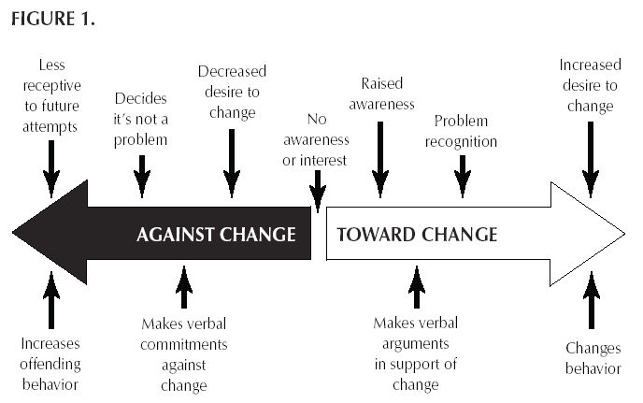

Figure 1. shows how motivational interviewing in the bipolar patient considering stimulant use can direct the person toward positive changes and help them make decisions that promote positive change. As awareness about the potential risks versus benefits increase, the patient is more driven toward positive changes in their thinking about medication choices. The ultimate change in behavior that is anticipated using motivational interviewing would be for the bipolar patient to be fully informed as to the choices available to treat ADHD symptoms other than a stimulant.

Goals and Strategies
The goal of this project is to review available evidence based literature to determine if the use of Vanderbilt Scale Screenings and Patient Health Questionnaire-9 assists in determining the presence of attention deficit hyperactivity disorder (ADHD) in co-occurring bipolar disease versus the patient having a worsening of bipolar symptoms that affect memory, cognition, attention span, focus, and concentration. The review is fundamental in implementing strategies that build practice guidelines for consistent evaluation and education of bipolar patients to either prevent erroneous prescribing for ADHD or to create a situation where concurrent treatment for ADHD and bipolar disorder is therapeutically needed. Proper screening and correct diagnosing is critical in distinguishing attention deficit hyperactivity disorder (ADHD) from the presence of bipolar disorder. There is good news for patients with concurrent ADHD and bipolar as treatment for the ADHD can consist of amphetamine salts so long as the manic symptoms are controlled with divalproex (Scheffer et al., 2005). Bipolar patients with co-morbid ADHD performs worse on tasks requiring attention and a working memory than those with bipolar disorder alone (Pavuluri et al., 2006).
State of the Science Paper 10
Patients with ADHD and co-morbid bipolar disorder show a much higher emotional intensity than those with bipolar alone (Richard-Lepourie et al., 2016). ADHD screening measures with the Vanderbilt Assessment Scale and bipolar depression screening tools using the PHQ-9 or the Mood Inventory Scale significantly helps discriminate between the presence of ADHD or the presence or elevated bipolar symptoms (Kitsune et al., 2016). Evidence demonstrates that patients in the United States (US) have an earlier onset of bipolar and childhood ADHD than patients in Europe. This is highly contributed to a greater family burden of psychiatric illnesses and the existence of more adversity in childhood in the US as opposed to Europe (Post et al., 2016). A childhood diagnosis or ADHD is a powerful indicator of juvenile-onset bipolar disorder. In 2016, Wang et al. completed a study that found that compared to ADHD patients that had never taken methylphenidate, patients with long-term use of methylphenidate were less likely to be diagnosed with bipolar disorder (Wang et al., 2016). Those researchers much like many other researchers in my literature review, say the exact mechanisms of the relationships among ADHD, its pharmacotherapy, and BD require further clarification in the future.
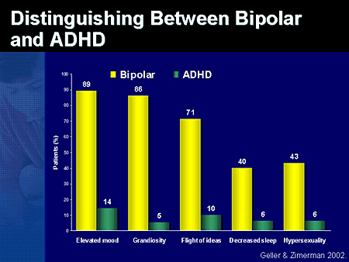
Differentiation Figure 1.

The question of distinguishing between ADHD and bipolar often arises in children and
adolescents, but it also happens during adult visits as well. Elevated mood, grandiosity, flight of ideas, decreased sleep, and hyper-sexuality are common traits associated with bipolar disorder, but are also present in ADHD, making it an important differential diagnosis in the psychiatric patient. In both disorders, there is a significant degree of variability in the symptom presentation (Ryden et al., 2009). Figure 1 shows that common symptoms associated with bipolar disorder also can be associated with the presence of ADHD, but at a much lower percentage. Diagnostic

State of the Science Paper 11
interviewing and thorough history taking are still our most valuable tools in differentiating between the two diagnoses.

It is important to ask patient certain questions during the initial process of distinguishing bipolar from ADHD. The clinician will want to know if the symptoms are episodic in nature. The clinician will also want to know if the symptoms occur during any week of the year or if the symptoms are present for days or weeks at a time then gone for weeks or months. These questions will assist the clinician in determining the correct diagnosis (Michelini et al., 2016). It is important for prescribers to know that ADHD does not start in adulthood, yet it is entirely possible that the person did not get the proper diagnosis in childhood. Current and past substance abuse should always be ruled out during any interview. Many times, simply correcting the person’s sleep hygiene habits will clear up any symptoms that appear to be bipolar or ADHD in nature (Post et al., 2016).

Not all mood swings are indicati8ve of bipolar disorder, just as not all focusing or concentration problems are indicative of ADHD. If the patient presents with mood shifts that occur on a daily basis, then other pathology such as anxiety or a panic disorder should be ruled out first. If the person has trouble paying attention of focusing on some things, but excels at focusing on other things, then an ADHD diagnosis might not be appropriate (Ryden et al., 2009).. Again, every situation is patient specific and it all depends on the level of experience of the clinician performing the evaluation. There are computer-based neuropsychiatric tests available on the market that can help distinguish the presence or absence of ADHD. These tests can also help the patient and the prescriber understand if common therapies for ADHD will be effective for the patient.

Treatment of Combined ADHD and Bipolar Disorder
There is a lack of published data out there to help clinicians determine the safest evidence based treatment for patients suffering from ADHD and bipolar concurrently. The research that is available does give hope to these patients. The bipolar mood disorder must be stabilized first in order for treatment to be successful. Generally speaking, this can be done effectively with the use of a mood stabilizing agent such as divalproex. Otherwise, there is a significant risk of triggering a manic episode when the clinician adds the ADHD treatment agent (Scheffer et al., 2005). Once the mood has been stabilized and residual symptoms resolved, then the clinician can introduce a first-line stimulant class of medication to treat the ADHD symptoms safely and effectively.
There is an alternative to the use of stimulants for those behavioral health specialists who treat ADHD and bipolar together. Bupropion, also known as Wellbutrin, is a non-Food and Drug Administration (FDA) approved medication used as a second line agent for the treatment of ADHD in all ages. Bupropion does provide non-stimulant significant benefits for treating ADHD symptoms and thus there would be no risk of triggering a manic or psychotic episode in the bipolar patient (Wang et al., 2016). Historically, the outcomes for treating both ADHD and bipolar together have thus far have been successful. Many patients seem to have not been
State of the Science Paper 12
hospitalized and even many more have been able to lead productive lives and work successfully. The general philosophy for successful treatment of both disorders lies in the fact that clinicians are aware that both disorders are present together and that both will respond to independent, coordinated, and separate treatment modalities. Many times it will be a trial and error phenomenon, but as long as the patient is stable and well cared for the outcome will be positive.
Clinical Scales: Vanderbilt Assessment Scale versus PHQ-9
The Vanderbilt Assessment Scale is a Likert type scale used by many behavioral health specialists to determine the presence and severity of ADHD symptoms. It is a self-report instrument that assesses both academic and behavioral problem areas. It is normally used in adolescents and children, but can be applied to adults since there is no real formal scoring instrument available for adult ADHD (Kitsune et al., 2016). A follow up reassessment might be useful once pharmacological interventions have been initiated. Appendix B shows a version most commonly used in practice by clinicians today. It is important to regularly assess the patient presenting with ADHD symptoms using this scale as changes in behavior can be tracked and progress with treatment monitored.
The Patient Health Questionnaire-9 or commonly referred to as the PHQ-9 is also a Likert type self-rating scale used by clinicians to help understand the severity of a patient’s moods and depression, specifically. It is used as a screening tool at each patient visit to track changes in mood, depression, anxiety, sleep, and appetite (Richard-Lepourie et al., 2016). It possesses good diagnostic sensitivity and can help the clinician determine if the bipolar patient’s moods are getting worse over time. It consists of 9 research based questions that are rated from 0 to 3 in severity. Lower PHQ-9 scores could mean better stabilization of mood and thus create an opportunity for the clinician to be able to treat the ADHD symptoms. These two tools combined will give the practicing prescriber a better and clearer picture of what is going on with the patient. They also can serve as a good starting point for conversation about treating ADHD in the presence of bipolar.
Discussion

Many of the studies identified in the literature review have the exceptional ability for generalization. One study was conducted in Europe with patients from various backgrounds than those in the United States. The studies varied in the number of participants. Those with larger number of subjects showed power and validity in the study. Most all of the studies
focused on neurocognitive functioning and how variances can be attributed to both ADHD and bipolar disease. One study did an excellent job at looking at the possible presence of ADHD in early onset bipolar disease versus late onset. The approach of motivational interviewing is one of collaboration in which the psychiatrist seeks to evoke the patient’s own recognition of the desirability of change (Levin et al., 2016). Pharmacological interventions were primarily the same with all studies centering upon the use of psycho-stimulants and their safety as the primary treatment intervention even in the face of bipolar mania. Most studies agreed that proper education for the patient is a critical step in establishing trust and allowing the patient to
State of the Science Paper 13
make independent and rational decisions about the use of stimulants. In order to elicit a long-lasting change in a patient's behavior, the patient has to first believe that they can make that change. Directing the patient to look at previous changes they have made can reinforce that belief.

Motivation interviewing is a critical step in educating bipolar patients about the use of stimulants. Putting effort towards relating to the bipolar patient and their perspective is the first step in educating the patient. Patients who feel they are better understood will be more willing to “open up” or express themselves to the clinician. Stimulant medications have significant abuse potential. It is very important to initiate a conversation with patients exhibiting ADHD symptoms who desire the use of stimulants. Motivation interviewing in the stimulant use discussion highlights individual patient goals and brings to the patient's attention how their current behavior is preventing them from achieving those goals. It is critical to let patients know that a boxed warning has been added to many stimulant medications due to their high potential for dependence and abuse. This is particularly important for a bipolar patient to understand due to the impulsivity and potential for substance abuse associated with a bipolar disorder diagnosis. Prescribers in psychiatry are increasingly being asked to balance an ADHD diagnosis with monitoring the patients' potential misuse of prescribed stimulants.

Correctly identifying, assessing, diagnosing, and ultimately treating ADHD-should it exist-in the presence of co-occurring bipolar affective disease in all age populations was the goal of this review. While a great deal of information is already known about effective ADHD treatment in bipolar patients, still little is known about differentiating ADHD symptoms from affective disorder exacerbations. Effective screening using standardized tools leads to better patient outcome and a resolution of symptoms as a whole. Challenging a patient's resistance to therapy can put them on the defensive, slowing progress. It is in the best interest of the provider to utilize these situations to explore the patient's reasoning and develop solutions to the problems they have presented. The best practice intervention is compliance by bipolar patients with their mood stabilizers. Once the mood is stabilized, it clears up any confounding question of whether or not the person’s behavior is a result of the emergence of ADHD or just a simple need for pharmacology review. Additional research is most certainly needed in the area of early intervention and appropriate screening for those bipolar patients who feel ADHD is a co-morbidity. The differentiation task most often is done in busy outpatient clinics, but clinicians will need refined skills at identifying ADHD and getting bipolar symptoms under control. Research does suggest that acute manic episodes of bipolar might require brief in-patient hospitalization whereas the emergence of ADGD symptoms generally does not. A lot of information has been gained in the past 10 years in this area of psychiatry, but more information and more studies are critically needed.

Recommendations

This review demonstrates that though there are a few promising approaches to identifying, diagnosing, and treating ADHD in the bipolar patient. Advanced practice nurses are in a unique
State of the Science Paper 14
position to serve as leaders in assessing patient appropriately for ADHD in the presence of bipolar. Further robust studies are needed to understand this phenomenon adequately and make necessary evidence based practices changes accordingly. It is also recommended that practitioners use the self-scoring scales at each patient visit and track the score numbers accordingly. This will give a better picture of progress versus decompensation and can greatly assist the clinician in his or her pharmacotherapy decisions. Patient should be encouraged to keep a mood journal at home and bring with them at each visit to discuss with the prescriber. This will help the clinician from the patients’ perspective see how the mood shifts from day to day. A
scoring system from 0=no mood changes to 10=severe mood changes would be a good example on how to do this.

There are many useful and innovative techniques to elicit change in a patient’s behavior such as reflective listening, normalizing, and decisional balancing, it is the sheer manner of the approach that is central to success and the success of motivational interviewing. Clinicians should keep in mind that motivation to change is elicited from the patient, and it is the patient's task to articulate and resolve their ambivalences. Direct persuasion is not an effective method for resolving ambivalence, or is it part of good and effective motivational interviewing. Counseling needs to be done in a quiet and eliciting style with the counselor being directive in aiding the patient to examine and resolve ambivalence. It is also important to keep in mind that readiness to change is not typically a patient trait but a direct product of interpersonal interactions throughout one’s life span. The therapeutic relationship is more comparable to a partnership than expert roles. Patient education and the face to face interactions are critically important in stabilizing the bipolar patient with ADHD symptoms. There is no one set method at treating this patient population and it might even be a trial and error endeavor to get the patient to a place where he or she needs to be. It always must start, however, with an open mind and willingness on the part of the prescriber and the patient alike. Clinical outcomes are better when the patient-provider relationship encompasses open and direct communication. Non-threatening but direct questions communicates a level of respect to the patient and should reduce the feeling of being pressured to participate in the conversation. This can be followed up by eliciting change talk and reflecting on what the patient is trying to get the provider to understand. Once a patient has decided to embark on a new journey and begins the change process, it is important to be supportive and give strong affirmations to their progress. Summarizing the session while providing advice and feedback allows the clinician to communicate their involvement with the patient and build on that connection.

The ultimate goal of using motivational interviewing in the bipolar patient considering the use of stimulants is not to solve the patient's ADHD problem or even to develop a plan for medication decision making. The real goal should be to help the patient resolve his or her ambivalence toward medication decision making and ultimately develop some momentum and believe that their behavior change is quite possible and not even very difficult to achieve. Because of everyday time constraints and advanced medical training, most psychiatric providers are quick to simply just give immediate solutions and not really consider the use of motivational interviewing to assist in patient education. However, doing so often denies the patient the opportunity to consider different courses of action and their associated benefits of various
State of the Science Paper 15
treatment modalities. Many times these courses of action are confusing, contradictory and deeply persona for the patient. Allowing the patient to explore these issues increases the chances that the patient may find an acceptable resolution and choose a path that is most beneficial to the patient’s health and well-being.

State of the Science Paper 16

References

Kallestad, H., Wullum, E., Scott, J., Stiles, T., & Morken, G. (2016). The long-term outcomes of
an effectiveness trial of group versus individual psychoeducation for bipolar disorders.
Journal of Affective Disorders, 202(1): 32-38
DOI: http://dx.doi.org/10.1016/j.jad.2016.05.043

Kitsune, G., Kuntsi, J., Costello, H., Frangou, S., Hosang, G., McLoughlin, G., & Asherson, P. (2016). Delineating ADHD and bipolar disorder: A comparison of clinical profiles in adult women. Journal of Affective Disorders, 192(1): 125-133.
Levin, J., Krivenko, A., Howland, M., Schlachet, R., & Sajatovic, M., (2016). Medication
adherence in patients with bipolar disorder: a comprehensive review. CNS Drugs, 30(9):
819-835. doi:10.1007/s40263-016-0368-x

Michelini, G., Kitsune, G., Hosang, G., Asherson, P., McLoughlin, G., & Kuntsi, J. (2016). Disorder specific and shared neurophysiological impairments of attention and inhibition in women with attention-deficit/hyperactivity disorder and women with bipolar
disorder. Psychological Medicine, 48(3): 493-504.

Nierenberg, A., Miyahara, S., Spencer, T., Wisniewski, S., Otto, M., Simon, N., Pollack, M., Ostacher, M., Yan, L., Siegel, R., & Sachs, G. (2005). Clinical and diagnostic implications of lifetime attention-deficit/hyperactivity disorder comorbidity in adults with bipolar disorder: Data from the first 1000STEP-BD participants. Biological Psychiatry, 57(11): 1467-1473.
Pavuluri, M., Schenkel, L., Aryal, S., Harral, E., Hill, S., Herbener, E., & Sweeney, J. (2006). Neurocognitive function in un-medicated manic and medicated euthymic pediatric bipolar patients. The American Journal of Psychiatry, 163(2): 286-293.
Post, R., Altshuler, L., Kupka, R., McElroy, S., Frye, M., Rowe, M., Grunze, H., Suppes, T., Keck, P., leverich, G., & Nolen, W. (2016). More illness in offspring of bipolar patients from the U.S. compared to Europe. Journal of Affective Disorders, 191(1): 180-186.
Randall, C., & McNeil, D. (2016). Motivational interviewing as an adjunct to cognitive behavior
therapy for anxiety disorders: a critical review of the literature. Cognitive and Behavioral
Practice, 1(1): 1-10. DOI: http://dx.doi.org/10.1016/j.cbpra.2016.05.003

Richard-Lepourie, H., Etain, B., Hasler, R., Bellivier, F., Gard, S., kahn, J., Prada, P., Nicastro, R., Ardu, S., Dayer, A., Leboyer, M., Aubry, J., Perroud, N., & Henry, C. (2016). Similarities between emotional dysregulation in adults suffering from ADHD and bipolar patients. Journal of Affective Disorders. 198(1): 230-236.
State of the Science Paper 17
Ryden, E., Thase, M., Straht, D., Aberg-Wistedt, A., Bejerot, S., & Landen, M. (2009). A history of childhood attention-deficit hyperactivity disorder (ADHD) impacts clinical outcome in adult bipolar patients regardless of current ADHD. Acta Psychiatrica Scandinavica, 120(3): 239-246.
Scheffer, R., Kewatch, R., Carmody, T., & Rush, A. (2005) Randomized, placebo-controlled trial of mixed amphetamine salts for symptoms of comorbid ADHD in pediatric bipolar disorder after mood stabilization with divalproex sodium. American Journal of Psychiatry, 162(1): 58-64.
Wang, L., Shyu, Y., Yuan, S., Yang, C., Yang, K., Lee, T., & Lee, S. (2016). Attention-deficit
hyperactivity disorder, its pharmacotherapy, and the risk of developing bipolar disorder:
A nationwide population-based study in Taiwan. Journal of Psychiatric Research, 72(1):
6-14.

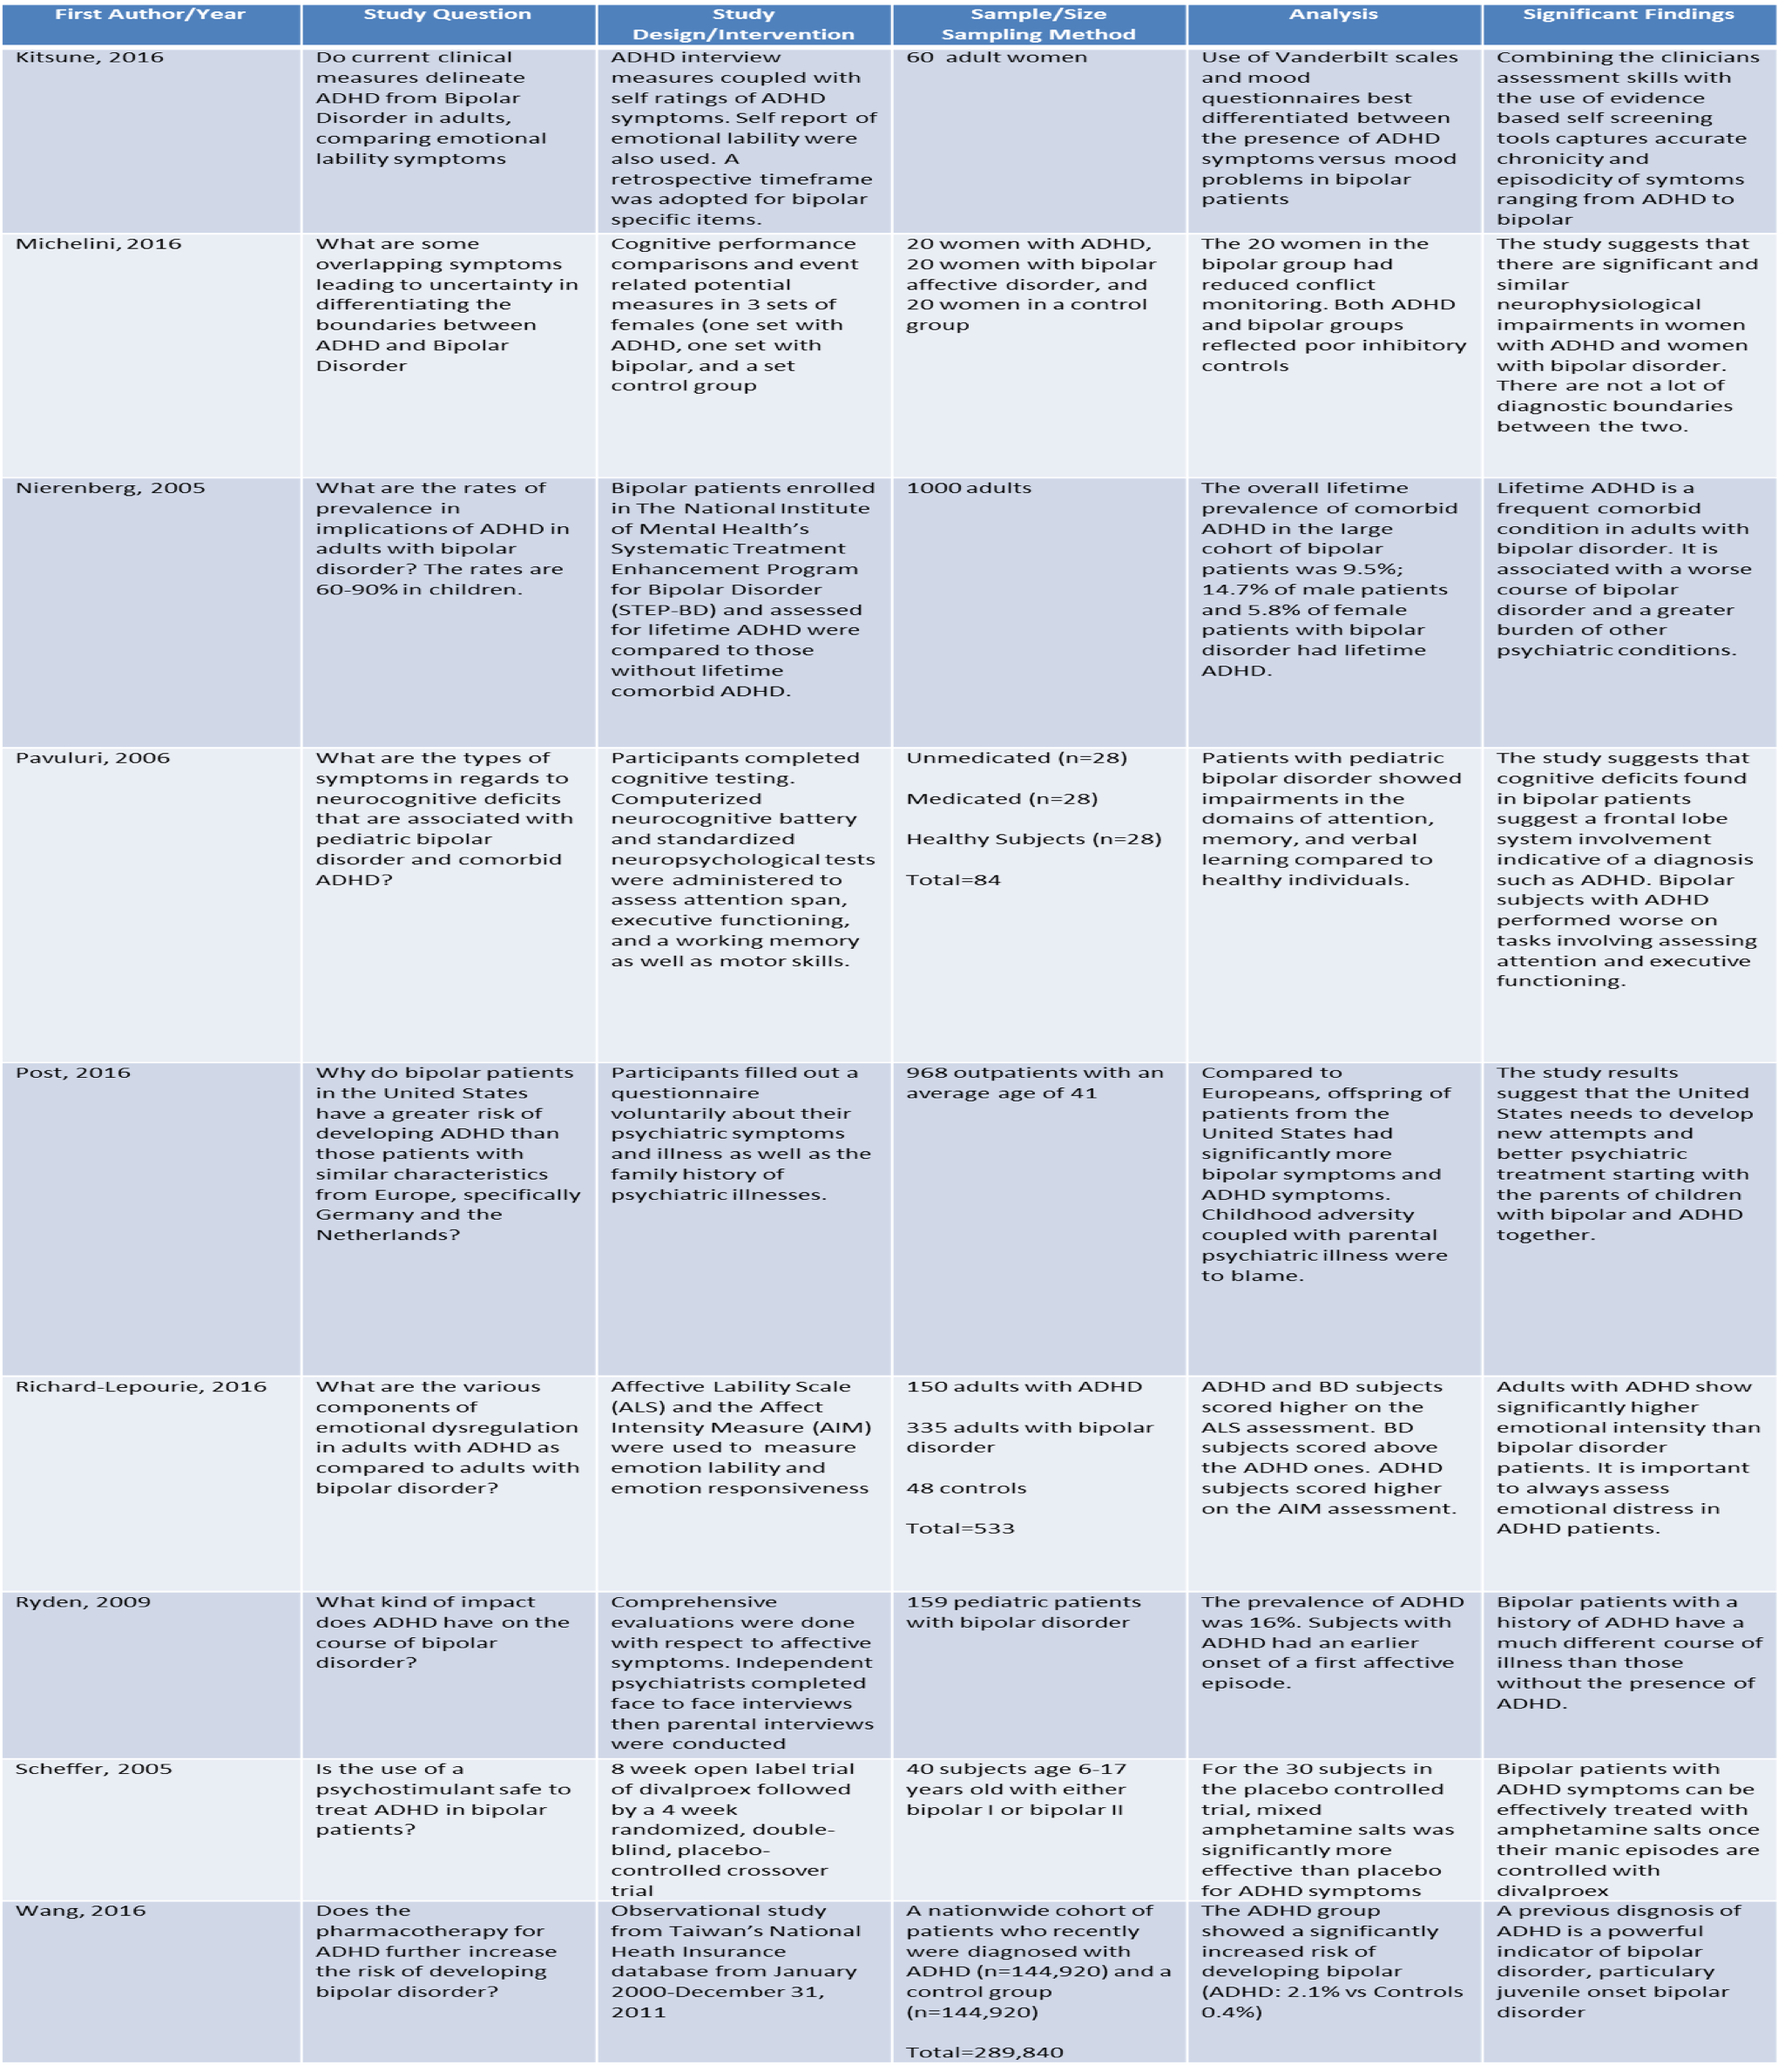
Appendix A: Evidence Table I
Appendix B. Evidence Table II Continued
First Author/Year | Study Question | Study Design/Intervention | Sample Size/Sampling Method | Analysis | Significant Finding
Kallestad, 2016 | Is group psychoeducation superior to individual psychoeducation for a heterogenous sample of patients with bipolar disorder recruited from general clinical settings | Shortest survival time, whilst GP cases without HSU survived the There were also group differences in survival time over 8 years, but treatment allocation alone was no longer a significant predictor of survival time (p=0.07). There was an interaction between group (GP/IP) and harmful substance use (HSU), such that GP cases with comorbid HSU had the longest (p=0.02). Also, GP cases had a small but significant reduction in hospital use compared with IP (p=0.04). | 85 patients with BD were randomized to receive 10 weekly sessions of GP followed by 8 booster-sessions over two years | Patients allocated to GP had longer survival time compared to IP over 27 months (p<0.0.5). | GP is superior to IP in delaying hospitalizations in a clinically representative population. However, GP did not prevent or delay admissions in BD patients with HSU.
Levin, 2016 | For adherence-enhancement approaches to be widely adapted, do they need to be easily accessible, affordable, and practical. | A comprehensive review of adherence-enhancement interventions for the years 2005–2015 is included. | N/A | Specific bipolar adherence-enhancement approaches that target knowledge gaps, cognitive patterns, specific barriers, and motivation may be helpful, as may approaches that capitalize on technology or novel drug-delivery systems. | Much work remains to optimally facilitate long-term medication adherence in people with BD. For adherence-enhancement approaches to be widely adapted, they need to be easily accessible, affordable, and practical.
Randall, 2016 | Is Motivational Interviewing (MI) appears efficacious as an adjunct to CBT for anxiety? | Findings are summarized from 6 case studies and uncontrolled trials and 11 randomized controlled trials published through March 2016. An integrated critique of this literature also is offered. | N/A | Limitations and the preliminary nature of the work in this area notwithstanding, it appears that it is feasible to supplement or integrate CBT with MI and that doing so has the potential to improve treatment initiation and engagement, as well as clinical outcomes | A number of directions for future research are addressed, such as determining which MI approaches to implement, with whom, when, and in what contexts.

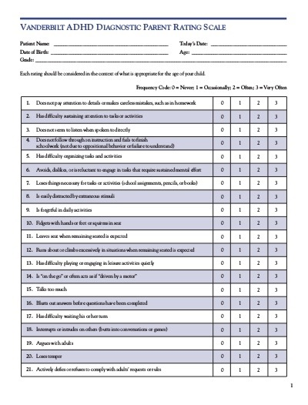
Appendix C. Vanderbilt Assessment Scale
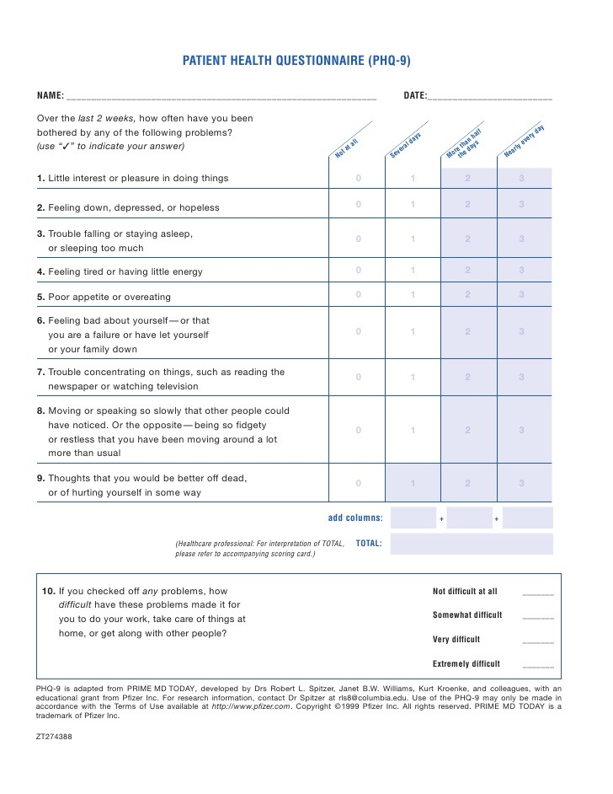
Appendix D. Patient Health Questionnaire-9 (PHQ-9)

